Results
The goal of this study was to determine if an intervention using the NAMI In Our Own Voices (IOOV) presentation with an anti-stigma educational session impacts mental illness stigma among undergraduate nursing students as measured by the OMS-HC 15. The intervention was guided by the Theory of Planned Behavior (TPB) and aimed to dispel mental illness stereotypes and myths through education while fostering positive contact by giving nursing students opportunities to hear from people who have lived with mental illness. This section presents the results of the statistical analysis to determine if there was a statistically significant difference between pre- and post-intervention OMS-HC 15 scores.
Research Question and Hypothesis
The following research question and its corresponding null hypothesis were tested:
R1: Is there a significant difference in the attitudes, help-seeking behaviors, and social distancing scores before the intervention among the participants?
H1₀: There was a significant difference in the attitudes, help-seeking behaviors, and social distancing scores before the intervention among the participants
H1_{a}: There is no significant difference in the attitudes, help-seeking behaviors, and social distancing scores before the intervention among the participants
Data Collection
Data were obtained using Qualtrics software in a pretest-posttest study design. A total of 29 undergraduate nursing students in the second semester of a baccalaureate nursing program at a public university in the Southeastern United States participated in the pre-intervention questionnaire, with only 11 participants completing the post-intervention questionnaire. In addition to presenting the 15 items of the OMC-HS 15, the questionnaire also collected basic demographic information. The data were analyzed using the SPSS Statistics Campus Edition 29 program.
Demographics of Sample
Table 1 provides an overview of the demographic features of the study's sample population. Gender, the presence of a friend diagnosed with a mental health issue, the presence of a family member diagnosed with a mental health condition, and age groups are among the categorical variables included in the data. The majority of participants were female, accounting for 89.7% of the sample, with men accounting for 10.3%. A total of 79.3% of respondents said they had a friend with a mental health condition, while 20.7% said they did not.
Pre-Intervention
Table 1
Demographic Characteristics of the Sample Population Pre-intervention
Categorical Variable | Frequency | %Total
Gender
Female | 26 | 89.7%
Male | 3 | 10.3%
Do you have a friend who has been diagnosed with a mental condition
Yes | 23 | 79.3
No | 6 | 20.7
Do you have a family member who has been diagnosed with a mental health condition
Yes | 22 | 24.1%
No | 7 | 75.8%
Age
18-24 | 26 | 89.7
25-34 | 1 | 3.4
45 years and older | 1 | 3.4
Not Disclosed | 1 | 3.4

Post-intervention
After the pre-intervention, only 11 participants continued for the post-intervention. There were no demographic data provided for the participants who continued for the post-intervention.
Results
Table 3 shows the descriptive statistics for the study's primary dependent and independent variables. The variables include the Total Stigma Score, which examines the total amount of mental illness stigma among participants and ranges from 20 to 42, with a mean of 33.28 and a standard deviation of 6.22. The Attitude Pre-Intervention Score, which ranges from 7 to 20, assesses participants' views toward people with mental illnesses before the intervention. The mean Pre-Intervention Attitude Score is 12.69, with a standard deviation of 3.19. The treatment-Seeking Pre-Intervention Score, which ranges from 4 to 18, assesses participants' desire to seek treatment for mental health difficulties before the intervention. The mean Pre-Intervention Help-Seeking Score is 11.31, with a standard deviation of 3.72. The Distancing Pre-Intervention Score, which ranges from 5 to 16, examines the extent of social distancing from individuals with mental illness before intervention. The mean Pre-Intervention Distancing Score is 9.28, with a standard deviation of 2.54.
Table 3
Descriptive Statistics of the Main Dependent and Independent Variables
 | N | Minimum | Maximum | Mean | Standard Deviation | Skewness | Kurtosis
Stigma Score | 29 | 20 | 42 | 33.28 | 6.22 | -.643 | -.299
Attitude Pre-Invention Score | 29 | 7 | 20 | 12.69 | 3.19 | -.304 | 0.97
Help Seeking Pre-Invention Score | 29 | 4 | 18 | 11.31 | 3.72 | -.133 | -.639
Distancing Pre-Invention Score | 29 | 5 | 16 | 9.28 | 2.54 | .225 | .448

Assumption Analysis
Before proceeding with testing the project hypothesis, it is necessary to ensure the data adheres to the assumptions of the One-Way ANOVA.
Assumption 1:
Since the dependent variables in the study are continuous numeric values, they are measured at the interval level. For instance, both "Disclosure Pre-Intervention" and "Disclosure Post-Intervention" are quantified (Delacre et al., 2019). Thus, this assumption holds for this set of data.
Assumption 2:
For One-Way ANOVA, two or more categorical, independent groupings should make up the independent variable (Delacre et al., 2019). The independent variable in this study is Q5, Q6, Q7, and Q8 and has numerous categories (e.g., "Yes" and "No"), which makes it appropriate for an ANOVA because it has independent groups.
Assumption 3:
The assumption of observation independence is met since each group has different participants (i.e., different rows in the dataset), with no participant being in more than one group (Delacre et al., 2019). Each row represents a different person, and their responses are unrelated to one another.
Assumption 4:
The data should be normally distributed with no outliers in the following Figure 1. The boxplot shows that are no significant outliers that can affect the nature of the data. Additionally, the histograms in Figure 2, Figure 3, Figure 4, and Figure 5 show that the main variables are normally distributed thus it is statistically correct to use One Way ANOVA for this data (Delacre et al., 2019).

Figure 1
A Box Plot Shows the Outliers in The Data
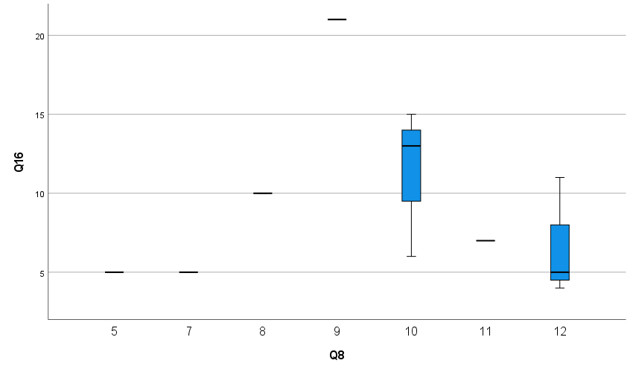
Figure 2
Histogram showing the normal distribution of Stigma Score Pre-Intervention

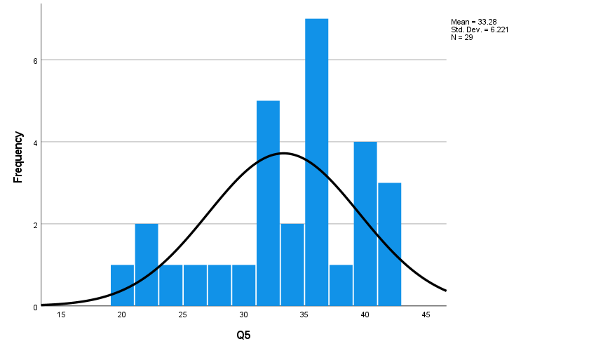

Figure 3
Histogram showing the normal distribution of Attitude Disclosure / Help Seeking Pre-Intervention

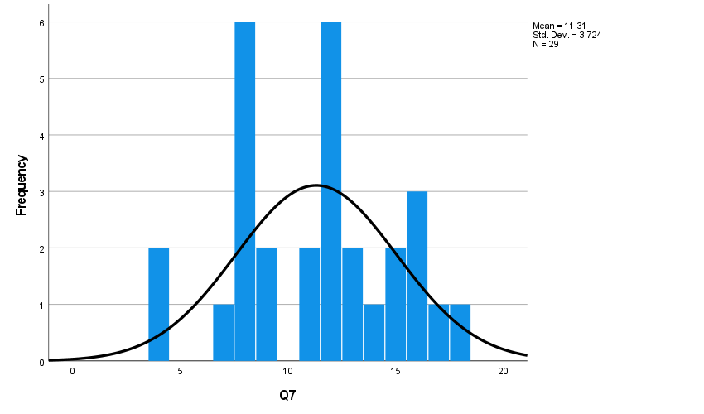

Figure 4
Histogram showing the normal distribution of Social Distancing Pre-Intervention 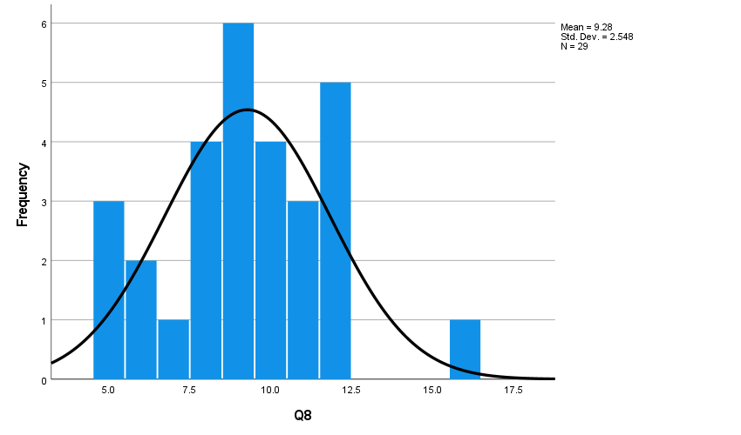

Figure 5
Histogram showing the normal distribution of Attitude Pre-Intervention
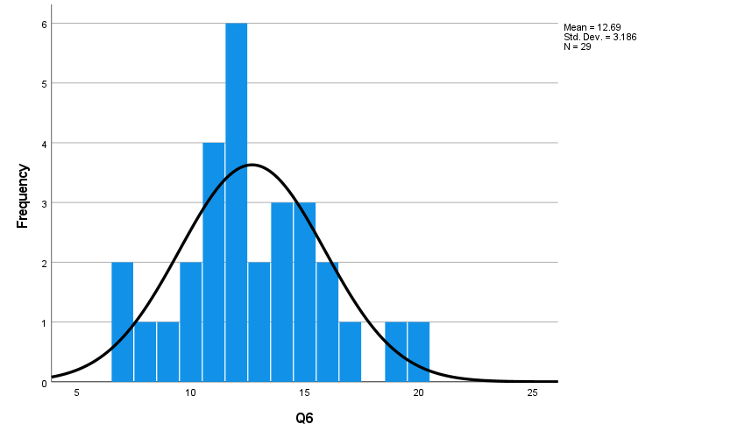

Results
Descriptive Statistics
This section explores the nature and statistical characteristics of the main dependent and independent variables. The three key dependent variables are the "Attitude Pre-Intervention Score," the "Help Seeking Intervention Score," and the "Distancing Intervention Score." These variables indicate participants' pre-intervention ratings on various subscales related to attitudes, help-seeking behaviors, and social distancing. The mean score for the "Attitude Pre-Intervention Score" is 12.69, showing the average attitude score before the intervention. The scores range from a low of 7 to a high of 20. The standard deviation is 3.19, indicating that the participants' attitudes vary moderately. The skewness is positive (0.304), showing that the distribution is slightly right-skewed, and the kurtosis is near 0.097, indicating that the distribution is normal with a slight peak.
"Help Seeking Intervention Score," has a mean of 11.31, which represents the average help-seeking behavior score before the intervention. The scores range from 4 to 18, with a minimum of 4 and a maximum of 18. The standard deviation is 3.72, showing that the participants' help-seeking behaviors vary significantly. The skewness is close to zero (-0.133), indicating a roughly symmetric distribution and the kurtosis is -6.39, showing a strong peak in the distribution. The mean score for the "Distancing Intervention Score" is 9.28, which represents the average social distancing score before the intervention. The ratings range from 5 to 16, with 5 being the lowest and 16 being the highest. The standard deviation is 2.54, showing that the participants' social distance ratings vary relatively little. The skewness is positive (0.225), indicating a somewhat right-skewed distribution and the kurtosis is 0.448, showing a higher peaked distribution than the normal distribution.
Table 3
Descriptive Statistics of the Main Dependent and Independent Variables
 | N | Minimum | Maximum | Mean | Standard Deviation | Skewness | Kurtosis
Attitude Pre-Intervention Score | 29 | 7 | 20 | 12.69 | 3.19 | .304 | .097
Help Seeking Intervention Score | 29 | 4 | 18 | 11.31 | 3.72 | -.133 | -6.39
Distancing Intervention Score | 29 | 5 | 16 | 9.28 | 2.54 | .225 | .448

Hypothesis Testing
To determine whether the null hypothesis should be accepted or rejected for each predictor, we must compare the p-values (Sig.) associated with the F-values to a predetermined significance level (e.g., 0.05). We reject the null hypothesis if the p-value is less than or equal to the significance level, showing that there is a significant difference between the groups. We fail to reject the null hypothesis if the p-value is greater than the significance level, indicating that there is no significant difference between the groups. We fail to reject the null hypothesis since the p-value (0.889) is bigger than 0.05, indicating that there is no significant difference between the pre-and post-stigma scores. We fail to reject the null hypothesis since the p-value (0.615) is greater than 0.05, indicating that there is no significant difference between the pre-and post-disclosure scores. We fail to reject the null hypothesis since the p-value (0.272) is greater than 0.05, indicating that there is no significant difference between the pre-and post-social distancing scores. We fail to reject the null hypothesis since the p-value (0.983) is greater than 0.05, indicating that there is no significant difference between the pre-and post-attitude scores. In summary, we fail to reject the null hypothesis for Post-Stigma, Post-Disclosure, Post-Social Distancing, and Post-Attitude based on the available data, indicating that there are no significant variations between pre-and post-intervention scores for these predictors.
Table 4
Fixed-Effects ANOVA results
Predictor | Sum of Squares | df | Mean Square | F | Sig.
Pre-Stigma | 1083.793 | 16 | 67.737
Post-Stigma | 219.515 | 7 | 31.359 | .345 | .889
Pre -Disclosure | 388.207 | 11 | 35.29
Post -Disclosure | 88.227 | 7 | 12.604 | .850 | .615
Pre-Social Distancing | 181.793 | 8 | 22.724
Post-Social Distancing | 212.848 | 6 | 35.475 | 1.935 | .272
Pre- Attitude | 284.207 | 12 | 23.684
Post- Attitude | 33.500 | 7 | 4.786 | .146 | .983

References
Delacre, M., Leys, C., Mora, Y. L., & Lakens, D. (2019). Taking parametric assumptions seriously: Arguments for the use of Welch’s F-test instead of the classical F-test in one-way ANOVA. International Review of Social Psychology, 32(1), 13.
Mishra, P., Singh, U., Pandey, C., Mishra, P., & Pandey, G. (2019). Application of student’s t-test, Analysis of variance, and Covariance. Annals of Cardiac Anaesthesia, 22(4), 407–411. https://doi.org/10.4103/aca.aca_94_19

